PRACTICAL NO 8:- QUERY BASED ON OPERATORS AND JOINS, SIMPLE AND NESTED QUERY

NAME:- RUPESH JAGDISH SONAWANE ROLL NO:-190

DIV:-B BATCH:-B7

**use rupesh_db**

**CREATE TABLE RUPESH(**

**ID INT PRIMARY KEY,**

**FirstName VARCHAR(50),**

**LastName VARCHAR(50),**

**DepartmentID INT,**

**Salary DECIMAL(10, 2)**

**);**

**INSERT INTO RUPESH VALUES (1, 'John', 'Doe', 1, 60000);**

**INSERT INTO RUPESH VALUES (2, 'Jane', 'Smith', 2, 70000);**

**INSERT INTO RUPESH VALUES (3, 'Bob', 'Johnson', 1, 55000);**

**INSERT INTO RUPESH VALUES (4, 'Alice', 'Williams', 3, 80000);**

**select * from RUPESH**

OUTPUT:-

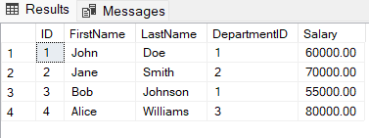

**CREATE TABLE RUPESH1(**

**DepartmentID INT PRIMARY KEY,**

**DepartmentName VARCHAR(50)**

**);**

**INSERT INTO RUPESH1 VALUES (1, 'HR');**

**INSERT INTO RUPESH1 VALUES (2, 'IT');**

**INSERT INTO RUPESH1 VALUES (3, 'Finance');**

**select * from RUPESH1**

OUTPUT:- 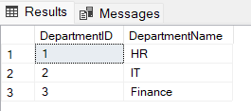

SELECT

e.ID,

e.FirstName,

e.LastName,

e.Salary,

d.DepartmentName

FROM RUPESH e

JOIN

Departments d ON e.DepartmentID = d.DepartmentID;

OUTPUT:-

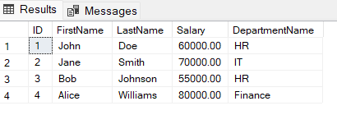

SELECT ID, FirstName, LastName,Salary,DepartmentID

FROM RUPESH WHERE Salary > (SELECT AVG(Salary) FROM RUPESH WHERE

DepartmentID =RUPESH.DepartmentID);

OUTPUT:-

